Media Release: April 2020
PR Contact: Jo at Spring PR
jo@springpr.com

New for spring/summer: Marmot’s Keele Peak Jacket with Pertex® Shield Pro
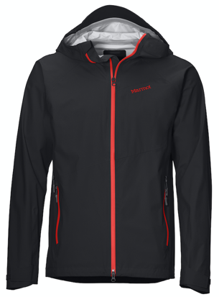
Marmot’s new Keele Peak Jacket, for men and women, is ideal for those heading out on the hills or mountains and wanting a lightweight (360g) waterproof, windproof and breathable jacket.

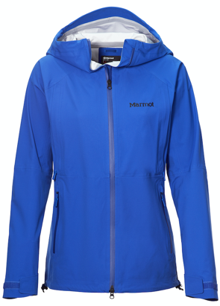
This fast and light shell has been designed with speedy ascents in mind. The 3-layer Pertex® Shield Pro fabric is windproof and waterproof, whilst offering high levels of breathability with plenty of stretch.

Pertex® Shield Pro uses a microporous membrane that has been engineered with a very high number of evenly spaced and interconnected pores. These pores allow any moisture vapour generated to pass through the fabric, minimising sweat build up and keeping you comfortable for longer. Check out the fabric technology in more detail here: https://vimeo.com/407904256

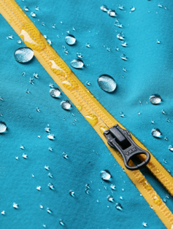
The Keele Peak Jacket has fully taped seams providing complete waterproof protection. It’s 2-way water resistant centre front zipper prevents bunching and the fabric’s 2-way stretch, plus articulated elbows, allow for freedom of movement. Built-in ventilation comes from core vents positioned on each side of the jacket and a helmet-compatible hood offers maximum coverage with an adjustable drawcord at the back that won’t interfere with the helmet. There’s also a handy front pocket that’s ideal for stashing a map. Everything you need from a jacket that will take up hardly any room in your backpack and ready to protect you from the elements whenever needed.

Details:
Sizes: Men’s: Small-XXL - Women’s: Small-XL
Colours: Men’s: Black, Enamel Blue, Team Red – Women’s: Black, Royal Night, Victory Red
SRP: £320

ENDS
About Pertex®
Pertex® was founded in 1979 by Hamish Hamilton. The brand is now a staple in the wardrobe of any outdoor enthusiast having established partnerships with some of the most reputable brands in the world.

