Media information: April 2020

Power through your home workout with Polartec

With swathes of the world currently on lockdown, now is the time to revise our April exercise plans. Gym memberships have been paused and gyms and yoga studios across the globe have started streaming their classes online so what better time is there to get stuck into your favourite exercise from the comfort of your own home.

Whether your chosen exercise is high intensity cardio or relaxing yoga sessions, it’s important that you’re wearing the right workout gear. With Polartec’s highly technical fabrics primarily engineered for outdoor use, it’s guaranteed that your clothing will be comfortable and breathable indoors too. We’ve hand-picked the latest, greatest pieces of Polartec kit, perfect for that home-work out whilst transgressing nicely into outdoor-wear for when we can once again embrace the countryside.

Yoga

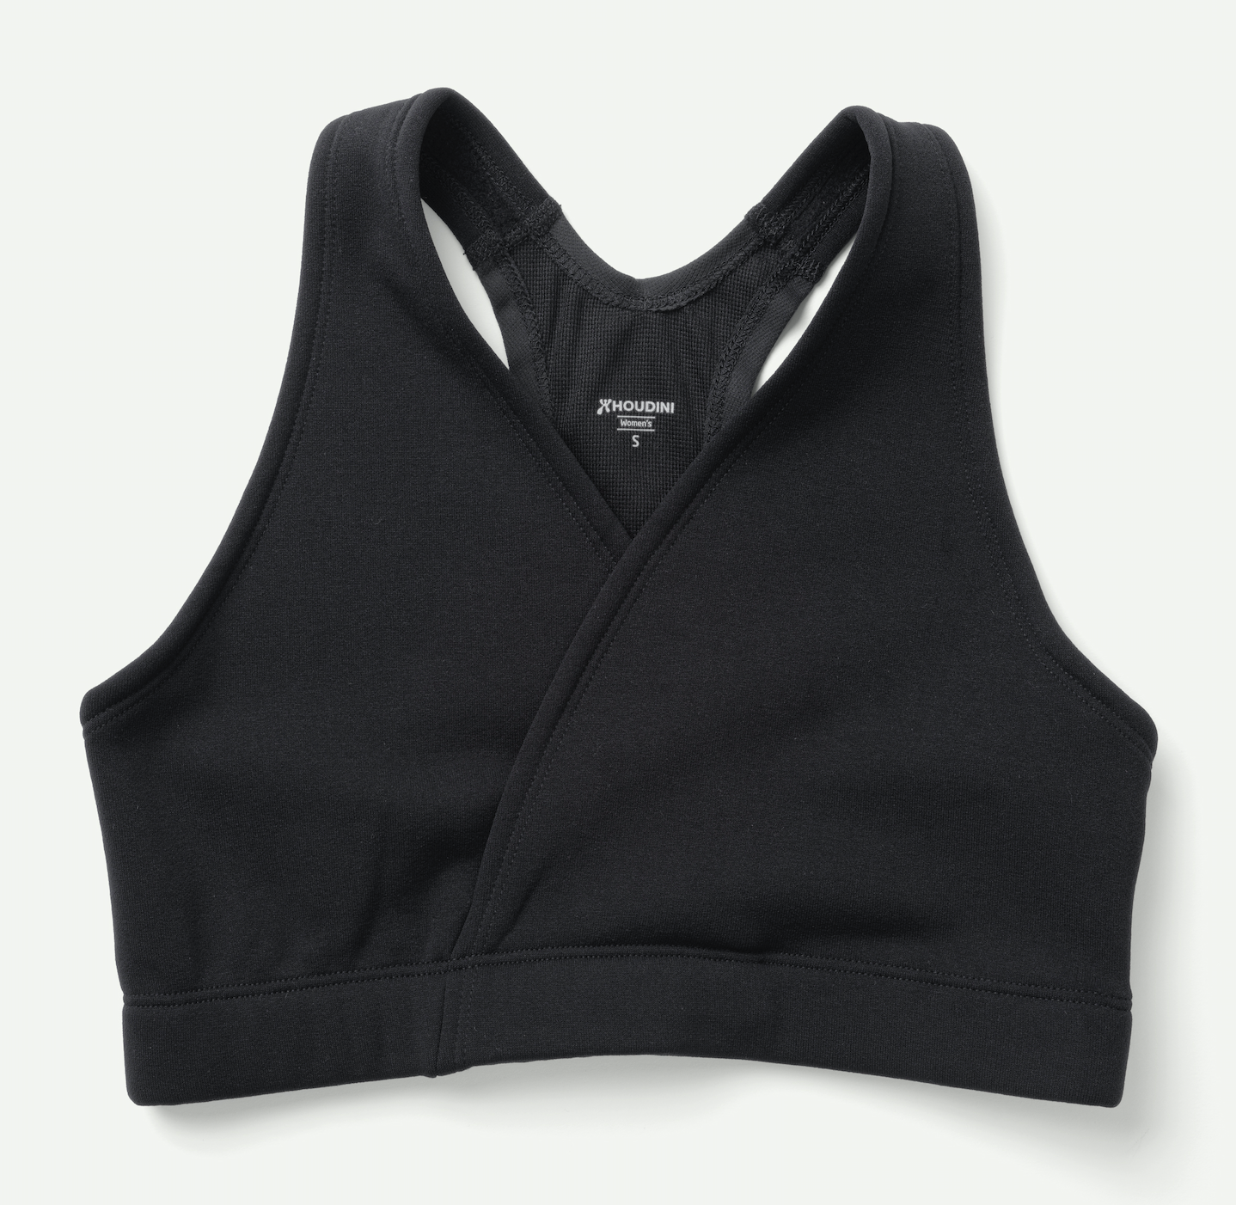
Houdini Women’s Mix Wrap Bra
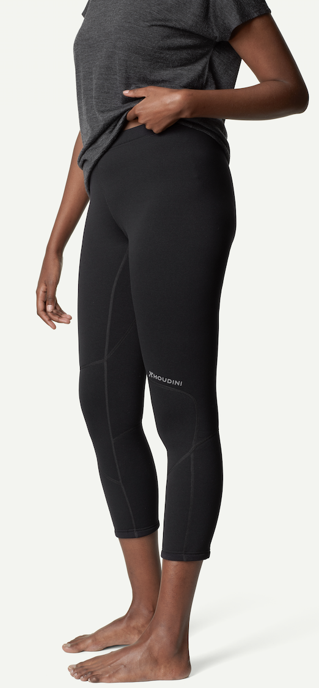
The Houdini Mix Wrap Bra is a fleece bra with light support. Made in Polartec Power Stretch Pro, it has a smooth and durable nylon surface and a soft fleece inside. It keep you warm and has excellent breathability. The quick dry bi-component construction and wicking microfleece inner helps transport moisture away from the skin. Available in XXS-XL the Mix Wrap Bra is an essential for a number of activities, such as yoga, running or just everyday comfort. €50.

Houdini Women’s Drop Knee Power Tights
The Houdini Drop Knee Power Tights are ¾ length fleece tights, made in Polartec Power Stretch Pro. With a warm fleecy inside and nylon reinforced smooth outside not only are these tights extremely durable, their performance wicking abilities mean that they can keep up with any activity, making them perfect for yoga sessions and beyond.
Available in sizes XXS-XL. €100

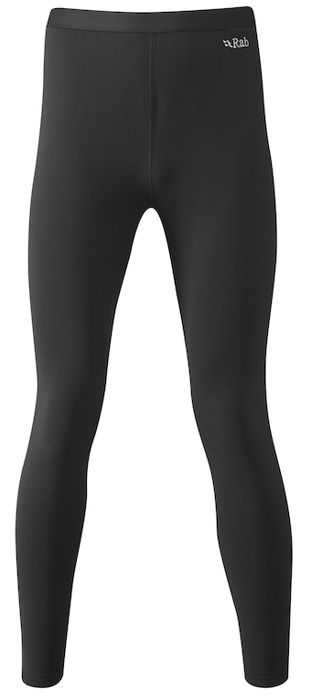
Rab Men’s and Women’s Power Stretch Pro Pants
Rab’s Men’s and Women's Power Stretch Pro Pants are light-weight fleeced, full-length pants, in Polartec® Power Stretch Pro®. Perfect as a base layer and for indoor workouts doubling as a mid-layer when the weather turns chilly. Available in sizes 8-16; S-XXL. £75

Indoor cycle training

British Cycling and Zwift have launched an eight-week virtual ride series to get people through the next couple of months and they’re not the only ones motivating people to keep exercising through creative means. Whether you’re cycling close to home or joining a virtual session, dress the part with the latest Polartec kit for cycling.

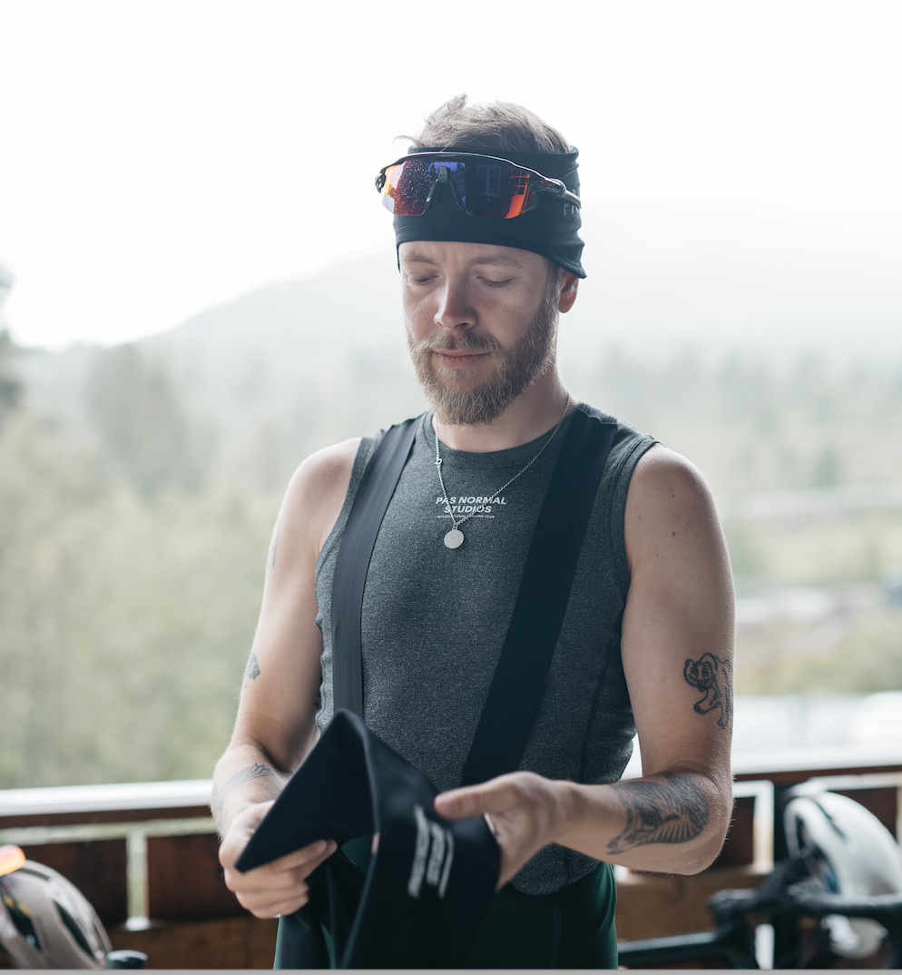
Pas Normal Control Mid Base Layer
The Pas Normal Control Mid Base Layer is a great choice for warmer days. Pas Normal has used Polartec’s Power Wool fabric to create a hybrid base layer tha t optimises moisture control, breathability and durability. Polartec Power Wool is a revolutionary, bi component knit fabric that combines the best of both natural and synthetic fibres, all without blending. With a merino wool interior and a synthetic fibre exterior, Power Wool’s advanced knit construction places each distinct fibre where it can work to its highest potential. The premium merino wool makes this piece naturally odour resistant while a high-efficiency grid backer traps warm air and aids in moisture transfer for quick drying. Available in various sleeve and colour combinations and sizes XXS-L. £75

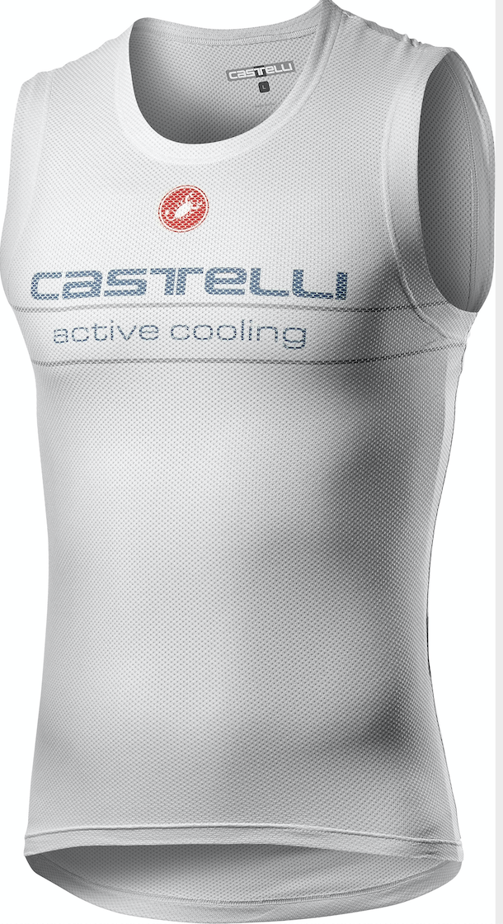
Castelli Active Cooling Sleeveless Base Layer
The Castelli Active Cooling Sleeveless Base Layer uses Polartec’s innovative Delta fabric, engineered to enhance the cooling of sweat. A perfect tee for at home training, this base-layer comes into its own in hot-weather cycling when conditions warm up and we’re back on the roads again. It works like this: using two different yarns, they work on a hydrophilic [water loving] and hydrophobic [water hating] mechanism. The water loving yarns draw moisture away from the skin holding some of it – without cling – just long enough to exploit the cooling properties of sweat. This moisture then evaporates through airflow escaping through the open-knit design. Available in S-XXL. £70.

High Cardio

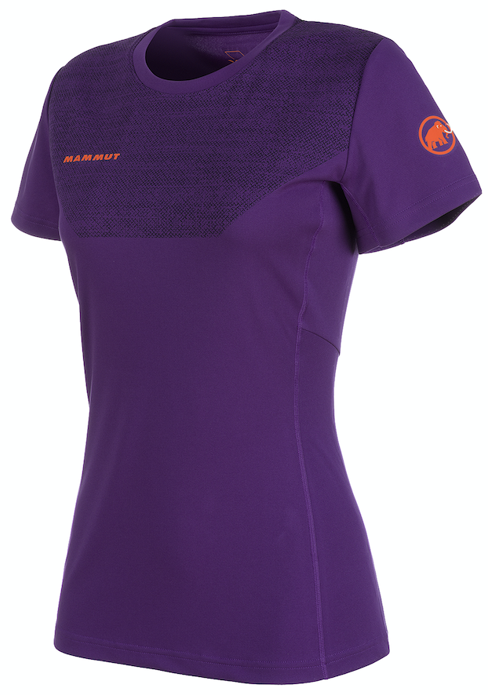
Mammut Moench T-Shirt
The colours of Mammut’s Moench T-Shirt are sure to encourage you to jump on that virtual training app. Using Polartec Power Dry, this has got to be the t-shirt of all t-shirts. Engineered for mountain challenges, the short sleeves and exceptional breathability and wicking properties will keep you dry throughout your work out. An antimicrobial treatment effectively reduces unpleasant odours too – so important when you’re working out in a confined space. Available for men and women; Sizes: S-XXL/XS-XL; £70.

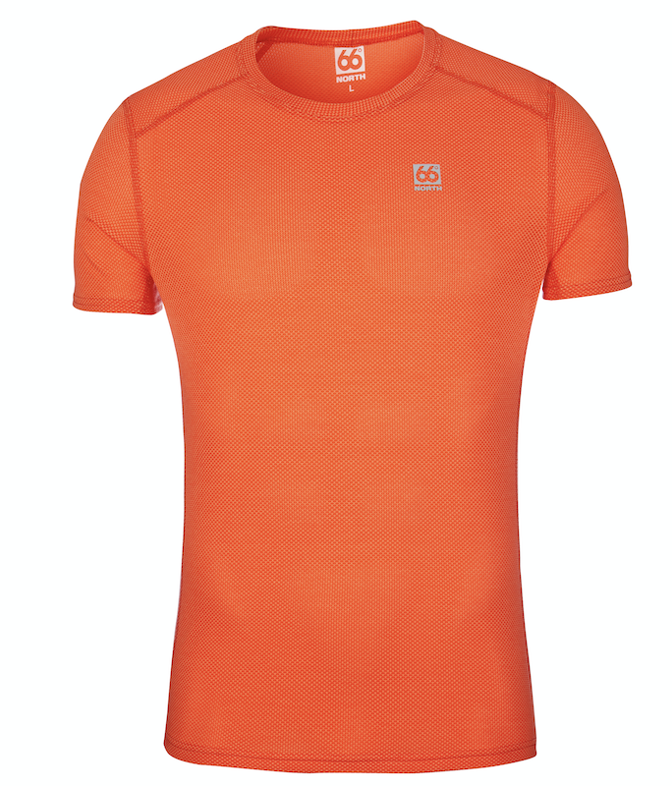
66° North Grettir Light T-shirt
If you’re planning on an intense workout then 66° North’s Grettir Light T-shirt
made with Polartec Delta is for you. Engineered to harness the cooling properties of sweat, this is a clever bit of kit. In a nutshell the fabric comprises hydrophobic [water hating] and hydrophilic [water loving] yarns. Sweat is pulled from the body through touch points [a grid-like structure of fabric that touches the skin] and then moved to yarns which hold onto the sweat just that little bit longer so that you can take advantage of sweat’s cooling properties before evaporating. And don’t worry, there’s no cling involved just a cooling and comfortable experience. Available for men; Sizes: XS-XL; £50.

Uses Polartec Power Dry for exceptional breathability and wicking properties.

Available for men and women; Sizes S-XXL [M]; XS-XL [W]; £70

For further information contact Stephanie Briggs at Spring PR:
Stephanie@springpr.com; T: 01666 800150
About Polartec: Polartec is the premium provider of innovative textile solutions. Since inventing modern synthetic fleece in 1981, the engineers at Polartec continue to create fabric technologies that solve problems and improve the way products are designed and used. Polartec products range from lightweight wicking and cooling fabrics, to insulation and weather protection textiles, and are utilized by leading consumer brands, the U.S. Military and other global militaries, flame resistance, workwear, and contract upholstery markets. For more information, please visit Polartec.com and follow Polartec on Instagram, Facebook and Twitter.

