Abbie Baynes | Spring PR
abbie@springpr.com | 01666 824180

LIFESTRAW HOME
The only filtering pitcher with next level protection
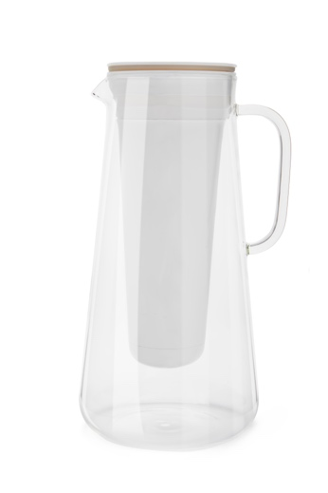
LifeStraw®, a global leader in developing innovative filtration and purification products for safe drinking water, introduces the LifeStraw Home water pitcher to the UK.

The seven-cup borosilicate glass water pitcher efficiently filters your tap water whilst looking sleek and stylish. A two-stage filtration system concealed within a white insert provides you with next-level filtration performance and fresh, clean tasting water. The first stage membrane microfilter removes bacteria, parasites and microplastics and last 1,000 litres. The second stage, an activated carbon and ion-exchange filter, reduces chlorine, heavy metals such as lead and mercury, pesticides and PFAS as well as unpleasant odors for two months/150 litres; removing the unfavorable elements but allowing vital minerals such as magnesium, potassium, carbon and sodium to pass through.

The LifeStraw Home pitcher filters 1,650 ml of water in approximately 12 minutes, comfortably fits in most fridge doors and is easy to pour one-handed. You no longer have to hide your filter in the fridge - the pitcher looks good enough for your table during a dinner party.

Each purchase has an impact. The LifeStraw Home and all replacement parts give back: one product, one school child, one year of clean water.

Details:
RRP: £54.99, Lakeland
Size: 285 mm x 163 mm
Weight: 1100 grams empty

