Media information: May 2020

Layering is the key to cycling in our unpredictable British spring weather.

It’s a well-known fact that layering is the key to keeping warm (but not too warm). When combined with a weatherproof outer, cyclists can both trap body heat and stop the wind and rain getting to their skin at the same time. But the key is using the right fabrics at the right time.

Top three fabrics for cyclists this spring

Polartec NeoShell – for the rain. Comfortably named the world’s most breathable waterproof fabric technology, NeoShell combines strength and durability with dynamic air exchange and a comfortable range of movement.
Polartec Power Shield Pro – for the wind. A three-layer fabric system which blocks the wind and deflects rain whilst allowing sweat to permeate out. The pinnacle of soft shell performance.

Polartec Power Wool fabric – for the cold. A bicomponent knit construction means each distinct fiber is placed where it can work to its highest potential. The soft, odor reducing, merino wool base sits next to skin underneath the highly durable synthetic exterior.

The release of three new jackets featuring Polartec fabric technology provide that final layer of reliable protection for road cyclists in the temperamental British spring weather.

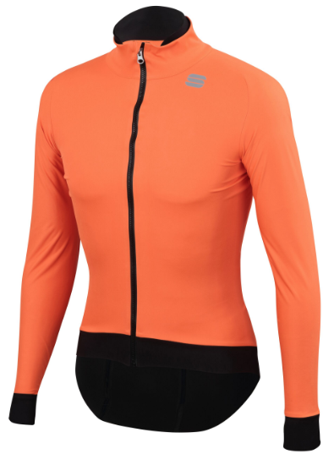
Fiandre, Pro Jacket powered by Polartec NeoShell
Also available in a short sleeved and a Medium-weight version, the Fiandre Pro is so called because of its preference by pro riders. Fiandre has incorporated Polartec to produce a cycling jacket that gives outstanding protection with high breathability in a fit designed to match the rider’s position on the bike. Strategically placed, fully taped, seams optimise fit and feel on the bike while reducing exposure to elements. Added features include reflective transfers on the back and three external rear pockets.

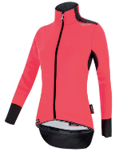
Santini, Vega Multi powered by Polartec Power Shield Pro
The Vega Multi is the ultimate choice for cyclists who don’t mind the rain. Power Shield Pro is combined with Santini’s Acquazeromoisture-barrier to result in a totally waterproof and thermowelded jacket (5,000mm water column); that’s still light, breathable and comfortable to wear. Ergonomically cut out waterproof sleeve cuffs and tail add to its effectiveness outdoors and a rear pocket with waterproof lining offers incredibly useful extra storage with protection. A reflective shoulder band and logo on the back tail provide reassurance for late cycles.

Santini has supplemented its collection with the hardwearing Sleeveless Base Layer and Under-Gloves featuring Polartec Alpha.

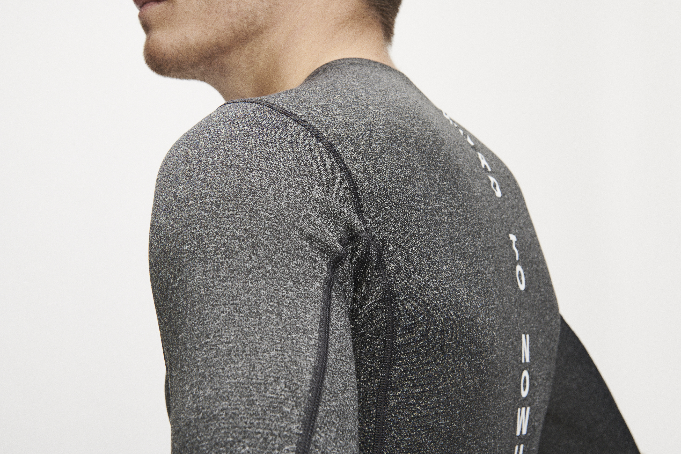
Pas Normal Control Mid Base Layer
The Pas Normal Control Mid Base Layer is a great choice for warmer days. Pas Normal has used Polartec’s Power Wool fabric to create a hybrid base layer that optimises moisture control, breathability and durability. Polartec Power Wool is a revolutionary, bi component knit fabric that combines the best of both natural and synthetic fibres, all without blending. With a merino wool interior and a synthetic fibre exterior, Power Wool’s advanced knit construction places each distinct fibre where it can work to its highest potential. The premium merino wool makes this piece naturally odour resistant while a high-efficiency grid backer traps warm air and aids in moisture transfer for quick drying. Available in various sleeve and colour combinations and sizes XXS-L. £75

For further information contact Stephanie Briggs at Spring PR:
Stephanie@springpr.com; T: 07818 063163
About Polartec: Polartec is the premium provider of innovative textile solutions. Since inventing modern synthetic fleece in 1981, the engineers at Polartec continue to create fabric technologies that solve problems and improve the way products are designed and used. Polartec products range from lightweight wicking and cooling fabrics, to insulation and weather protection textiles, and are utilized by leading consumer brands, the U.S. Military and other global militaries, flame resistance, workwear, and contract upholstery markets. For more information, please visit Polartec.com and follow Polartec on Instagram, Facebook and Twitter.

