Salewa x Polartec – Sustainable Innovation in the Dolomites

A recent collaboration took Polartec to the autonomous province of South Tyrol in Northern Italy. Bordering Austria, the region stands at a cultural crossroads (in fact, a majority of the population speaks German) and is home to the mighty Dolomites and mountain sports brand Salewa — one of the original all-sport outdoor brands. Salewa identifies so closely with the Dolomites, their new headquarters in Bolzano was designed to emulate their craggy peaks.

Salewa's connection to their local environment goes beyond an aesthetic choice. The headquarters is the first building in Italy to receive the KlimaHaus Work & Life certification. It boasts an organic garden that supplies top restaurants, employees, and neighbours with fresh produce; a solar roof that produces enough green energy to share with surrounding buildings; and one of the biggest climbing gyms in Europe. Protecting the environment and giving back to the climbing community are two key elements of Salewa's brand.

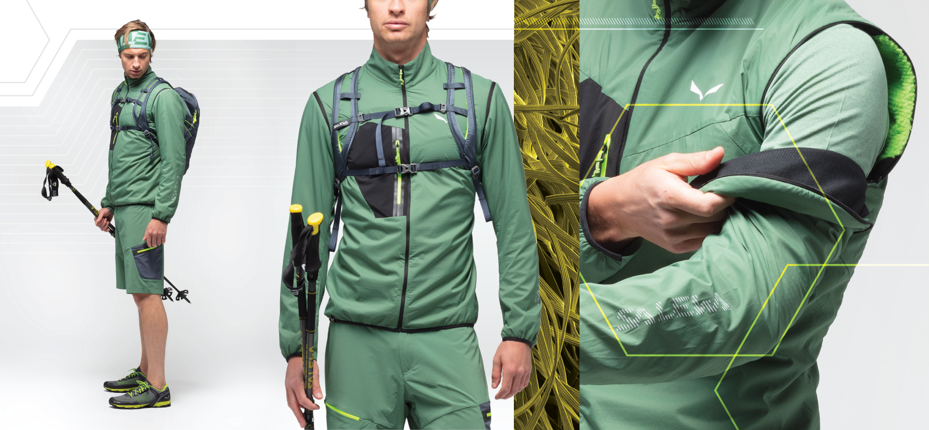

That's why Salewa's no stranger to Polartec’s recycled fabric platforms. This season, we're excited to unveil their slickest uses of recycled Polartec® Alpha® to date: the Pedroc Hybrid 2 Polartec® Alpha® Men's Jacket and Pedroc Hybrid Wind Polartec® Alpha® Men's Jacket. Alpha Active Insulation, now available made from 100% recycled content, was originally engineered for the U.S. Special Forces to deliver responsive warmth and greater breathability in extreme temperature variations and start-stop activities. This adaptability is ideal for speed hiking and mountaineering and is integral to the success of Salewa's Hybrid collection, the official jacket of the Red Bull X-Alps event.

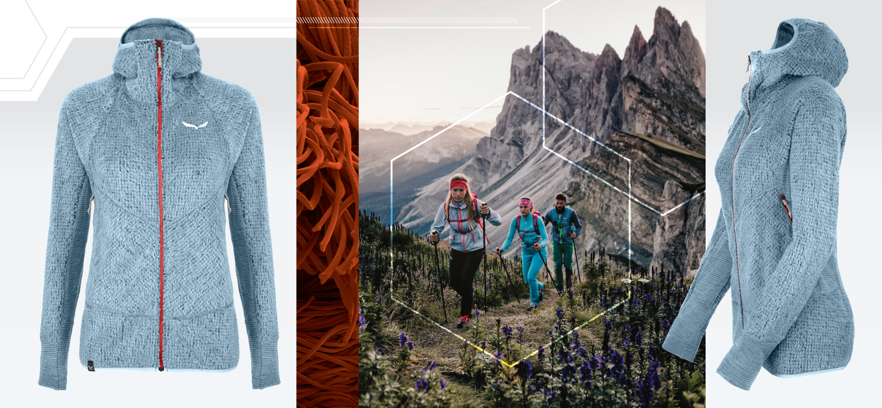

Beyond their love for Alpha's versatility, Salewa has also used the synthetic Polartec® High Loft™ to take their hoodies to new heights in past seasons. But Salewa was determined to get back to the roots of their brand by using more natural materials and knew they could trust the Science of Fabric to find the solution. They wanted to integrate wool fibres into a platform that already delivered so much for their customers. This set the stage for the next step in our partnership: a chance to evolve High Loft with Merino wool.

Playing off the natural breathability and thermoregulation of Merino wool, our Product Design Team produced a new version of High Loft for the Ortles Polartec® Wool High Loft Hoody, available in cuts for men and women.

In this newly designed fabric, layers of Merino wool are connected to both sides of a synthetic core to produce an advanced performance textile with the natural performance of wool and superior structural integrity of a synthetic. When used in the Ortles hoody, the result is a soft, natural feel that makes it the most comfortable layer possible for ski mountaineering and ice climbing. The High Loft with wool delivers all the features of the synthetic High Loft but with a natural material that stays true to our partner's brand story.

Polartec’s collaboration with Salewa is a special case-in-point because they met their customers' needs with a natural solution that was essential to their brand values. Keep an eye out for more Salewa x Polartec content this month and check out all the garments they’ve designed together over the years on the website. As always, the Science of Fabric continues to find fabric technologies and design solutions for any need and any reason. Salewa Ortles Polartec High Loft Hoodie avaliable for men and women, SRP £180.

About Polartec, LLC: Headquartered in Andover, Massachusetts, Polartec is the premium provider of innovative and sustainable textile solutions, combining innovation with eco-engineering to provide relevant, market-applicable textile solutions. Since inventing modern technical fleece in 1981, the engineers at Polartec continue to advance the science of fabric, creating fabric technologies that solve problems and improve the way products are designed and used. Polartec products range from lightweight wicking and cooling fabrics, to insulation and weather protection textiles, and are utilized by leading consumer brands, the U.S. Military and other global militaries, flame resistance, workwear, and contract upholstery markets. For more information, please visit www.Polartec.com and follow Polartec on Instagram, Facebook and Twitter.

