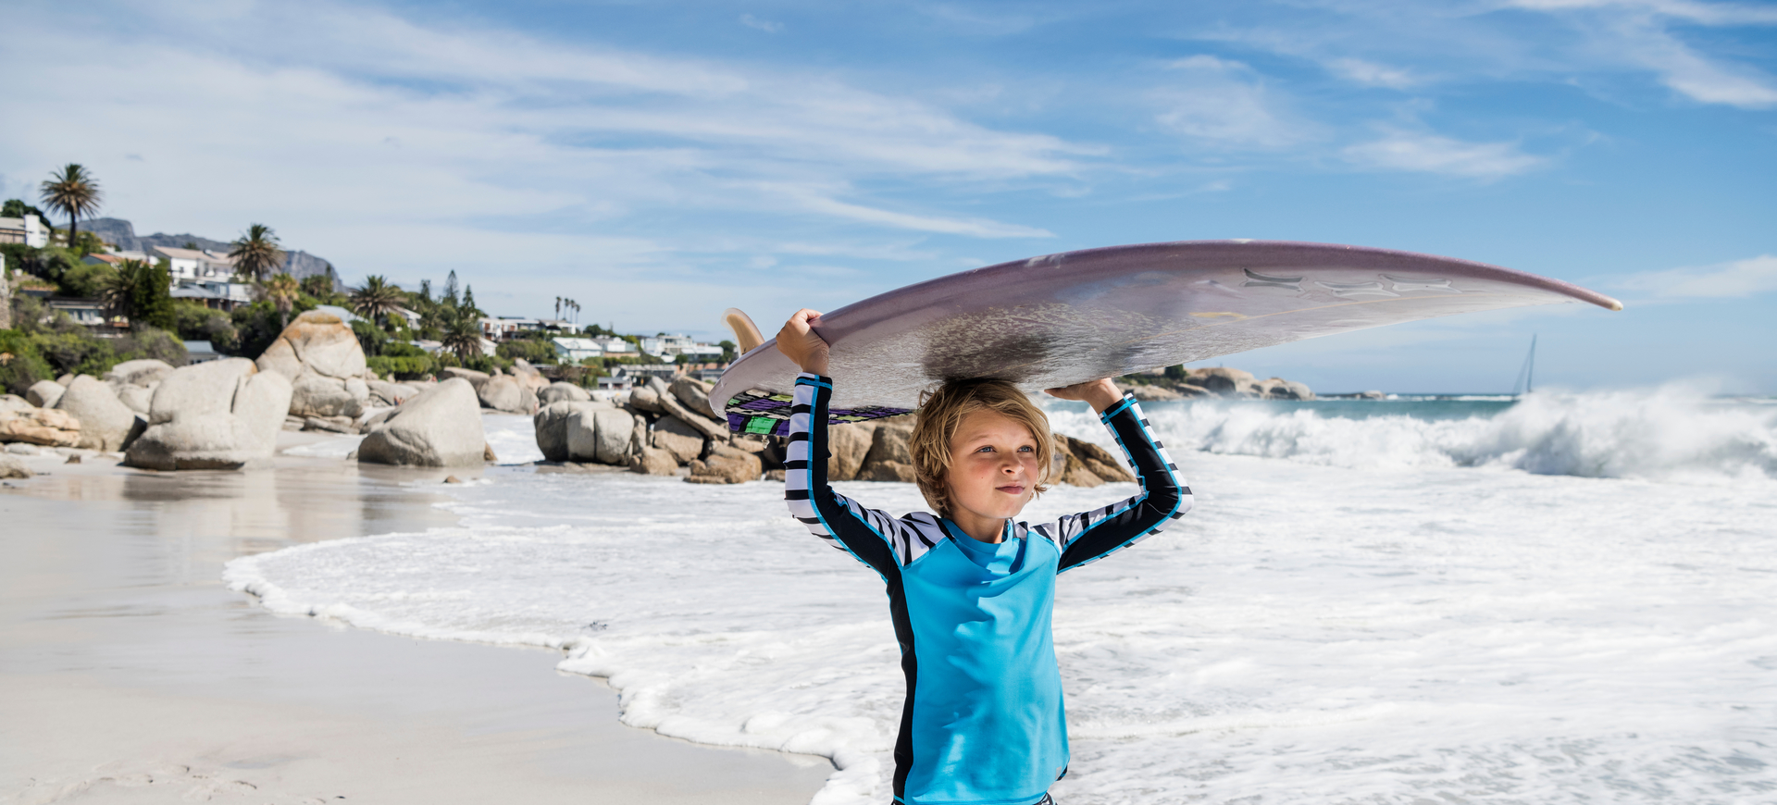

Reima UV protective wear recycles PET bottles

Leading kids activewear brand, Reima, launches its SS20 range of SunProof clothing, designed to protect against UV rays while enduring time thanks to clever, sustainable design

Founded in 1944, Finnish company, Reima Oy, is the world’s leading kids-only activewear brand. The brand has grown since laying down its roots in World War II and now creates kids’ clothing for all climates. Reima’s aim is to create sustainable wear that enables free play, unrestricted movement and learning by doing, for ages from 0 to 12. Therefore, all Reima apparel and footwear are designed to be easy to care for, to last from one user to the next and to help kids feel comfortable in any weather.

Kids need protection from sunburns

The adverse health effects of sunburns at an early age are increasingly well known. Keeping skin covered will protect it from harmful UV rays, but our everyday clothes can offer limited protection and will gradually expose skin to the harmful effects of sunlight. Depending on the thickness of the fabric, the protection factor of a regular white cotton t-shirt can be as low as 5 or 10.

Reima SunProof garments have been available since 2011. All Reima SunProof garments undergo a standard lab test for UV protection*. The testing ensures that the clothes provide a reliable sunblock for kids. The UV protection factor is marked on the hangtag and the clothes, to help parents estimate the protection capability of the garment.

Reima SunProof offers safe, non-toxic protection

Most Reima summer garments are highly UV protective by nature, based on the fabric structure, and others have a protective substance tightly bonded to the fibers of the fabric. All Reima UV protective clothing is non-toxic and safe to wear, independent of the protection method used.

Less lotion in the ocean

By using Reima SunProof UV protective clothes, parents can achieve up to 50 times longer playing time in the sun for their kids, and simultaneously decrease the consumption of sunscreen lotions.** With sun protection clothes that have UPF 50+, a kid whose skin would normally burn in 30 minutes when unprotected will enjoy 25 hours of safe playtime – and that’s much longer than the Sun will be up!

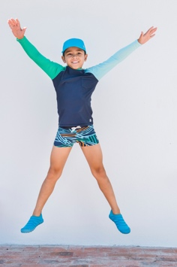
Recycling and digitalising to save resources

In summer 2020, Reima introduces new solid colour swimwear jersey. Its main material is high-quality recycled Repreve polyester, spun entirely from post-consumer PET beverage bottles. (Pictured right, Tioman, SRP €34.95/£31.00)

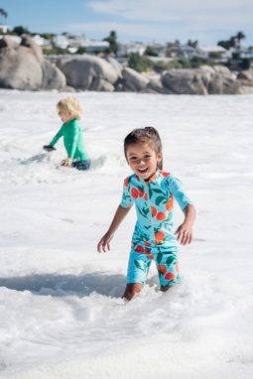

The printed Reima SunProof swim jersey gets its beautiful, bright patterns in digital printing, which needs less dyestuff and water than traditional textile printing. The protective substance in both jersey types is the safe, white pigment TiO₂ that is spun deep inside the fibres and will not wear off in the wash. (Pictured left, Galapagos swimsuit, SRP: €44.95/£41.00).

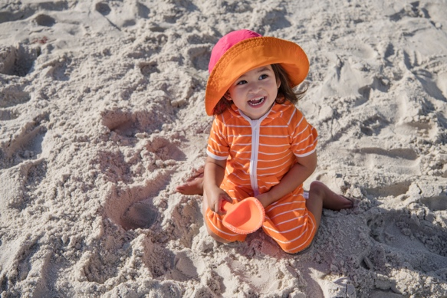
Comfortable after-swim wear with Tencel

The super soft Reima SunProof terry wear is at its best on the beach after swimming and as all-round holiday leisure wear. Quick-dry and with a natural UPF 50+, it will keep kids cosy and protected. The light, airy terry gets its premium softness and absorbance from sustainable Tencel. (Pictured right, Oahu terry all-in-one SRP: €34.95/£31.00).

For images & information, please contact:

Abbie Baynes | Spring PR

abbie@springpr.com | 01666 800150

---

*The UPF value of Reima wear is tested in external laboratories according to standard AS/NZS 4399: 1996.

**Many UV-filtering substances found in sunscreen lotions are reported harmful to aquatic organisms and can even damage coral reefs. By using SunProof wear instead of lotions, Reima consumers can help preserve marine life by decreasing the amount of chemicals that end up in the water.

Reima is a globally leading kids' activewear brand. Founded in Finland in 1944, Reima employs around 500 people. The company’s turnover was €141 million in 2019. Reima’s products and Finnish Baby Box solutions are available in over 70 countries. Reima’s mission is to gear up the next generation of happy, active kids, preparing them for the world to come. Our design principles are innovation, functionality, safety, and fresh Finnish design. The clothing is approved by the world’s toughest testers: children. Read more at www.reima.com

