Hydro Flask unveils new coffee lid

Author David Lynch once said, “Even bad coffee is better than no coffee at all.” Bad coffee? There should be no such thing.
Since 2009, Hydro Flask has successufully pursued its mission to save the world from lukewarm. Now, it’s introducing the new coffee lineup featuring the new Flex Sip™ lid. This wide mouth lid pairs the popular Flex Strap with an all-new, leak-proof lid design that twists to unlock the Smooth Flow Opening for the best on-the-go coffee experience.

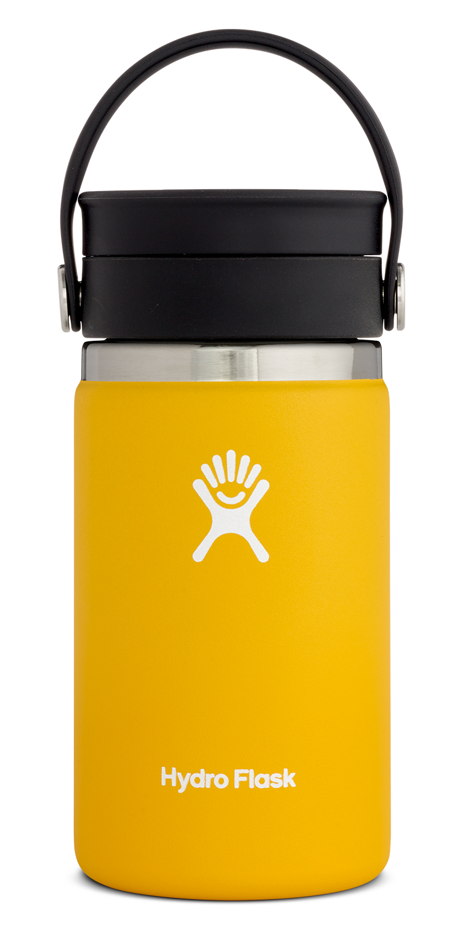
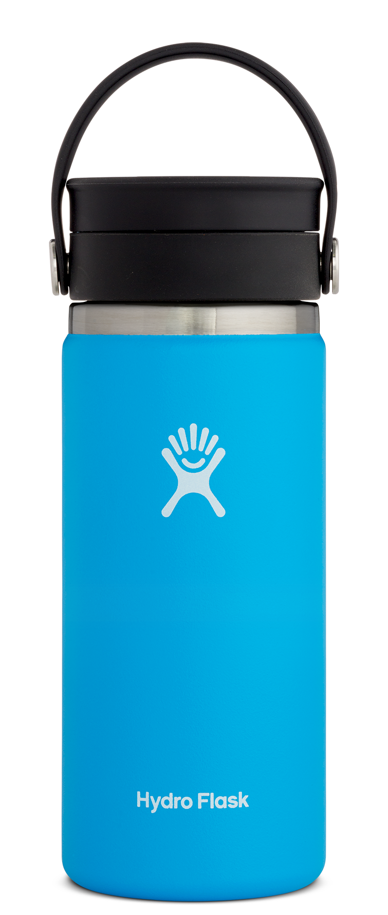
The proprietary Honeycomb Insulation™ works in tandem with Hydro Flask’s TempShield™ double wall vacuum insulation that, in turn, keeps your beverage hot for up to 12 hours in the 16 oz, and six hours for the 12 oz flask and both cold for up to 24 hours. Compatible with all of the Wide Mouth bottles, the Flex Sip Lid features stainless steel pivots and an easy-to-carry flexible strap. It is easily disassembled for cleaning.

The Hydro Flask coffee range includes 12 oz and 16 oz sizes that match your favourite coffee shop in an attractive and durable bottle, so you can get your caffeine fix without adding a disposable cup to the mix. The 18/8 pro-grade steel resists condensation, prevents breakage and also protects against heat and light making it the ultimate material for the perfect coffee flask. What’s more it won’t retain flavours so today’s chai latte won’t taste like yesterday’s cappuccino.

Details:
Hydro Flask 12 oz Coffee: £28.95, 16 oz Coffee: £31.50 and 20 oz Coffee: £32.95, Wide Mouth Flex Sip™: £12.95. Each of the new Flex Sip™ Coffee products will be available in seven colours.

About Hydro Flask
Hydro Flask is the award-winning leader in high-performance, insulated stainless steel beverage and food flasks. Founded in 2009 in Bend, Oregon, Hydro Flask is committed to bringing customers Unexpected Refreshment each and every time through the unique combination of temperature, taste and transport. Every bottle features TempShield™ double wall insulation to keep beverages at the desired temperature, 18/8 pro-grade stainless steel to ensure pure and refreshing taste, and durable powder coat and ergonomic design for the ultimate in transport. Hydro Flasks are stylish, BPA-free, recyclable, and backed by a lifetime warranty. Our new giving program, Parks for All, supports the development and maintenance of public green spaces, so people everywhere can live healthier, happier and more fulfilled lives. Learn more about Hydro Flask, Parks for All, and our mission to save the world from lukewarm at www.hydroflask.com.

