Abbie Baynes | Spring PR
abbie@springpr.com | 01666 824180

LIFESTRAW® GO 2-STAGE WATER BOTTLE

LifeStraw®, a global leader in developing innovative filtration and purification products for safe drinking water, introduces its LifeStraw Go 2-Stage water bottle. It features two-stage filtration, removing bacteria, microplastics and protozoa to make microbiologically contaminated water safe to drink, while also reducing organic chemicals, chlorine and bad taste.
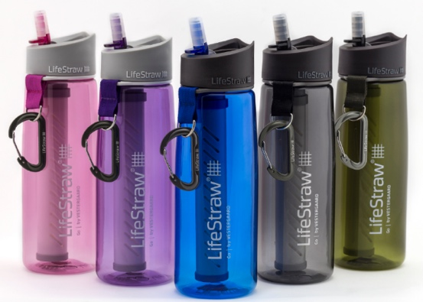
The new LifeStraw Go 2-Stage is engineered for a broad range of activities, from hiking, running and traveling to everyday use at work, home or the gym. Users can express their personal style by choosing their bottle in pink, purple, grey, green or blue. LifeStraw Go 2-Stage weighs under 227 grams and holds 0.65 litres of filtered water that meets stringent US EPA standards. It features a flip top bite valve and carabiner, is BPA and chemical free, and raw materials meet US FDA regulations.
“The LifeStraw Go 2-Stage bottle is an evolution of the original LifeStraw Go. It has enhanced functionality in that it also reduces chlorine, organic chemicals and bad taste,” said Alison Hill, LifeStraw’s Managing Director. “This new product helps us achieve our goal to provide products people can integrate into their daily lives and feel secure about the water they drink.”
The LifeStraw Go 2 uses a two-stage filtration process. Stage one is a hollow fiber membrane that removes 99.9999 percent of bacteria (E. coli and salmonella), 99.9 percent of protozoa (Giardia, Cryptosporidium, etc.), and reduces turbidity by filtering particulate matter to 0.2 microns. Stage two is an activated carbon capsule that reduces chlorine, organic chemical matter (like herbicides and pesticides), and bad taste. The hollow fiber membrane filters up to 1,000 litres throughout its life; the carbon capsule filters 100 litres. Replacements for both are available.

Details:
RRP: £45.95
Weight: 227 g
Volume: 650 ml
Colours: Pink, Purple, Blue, Grey, Green
Stockist: Wildbounds.com

