Media information: 1st July 2020

Polartec’s Would Be-ISPO Round-Up for SS21

In the absence of our favourite Munich-based outdoor trade show, here at Polartec we’ve decided to showcase the very best of Polartec inspired gear for next year. We’ve collated all the latest innovations from our customers and selected some key highlights planned for spring/summer 2021. New styles include a range of Polartec technologies from our cooling fabric Delta to our on-the-go warmth that is Alpha and everything in between. Here’s our round up:

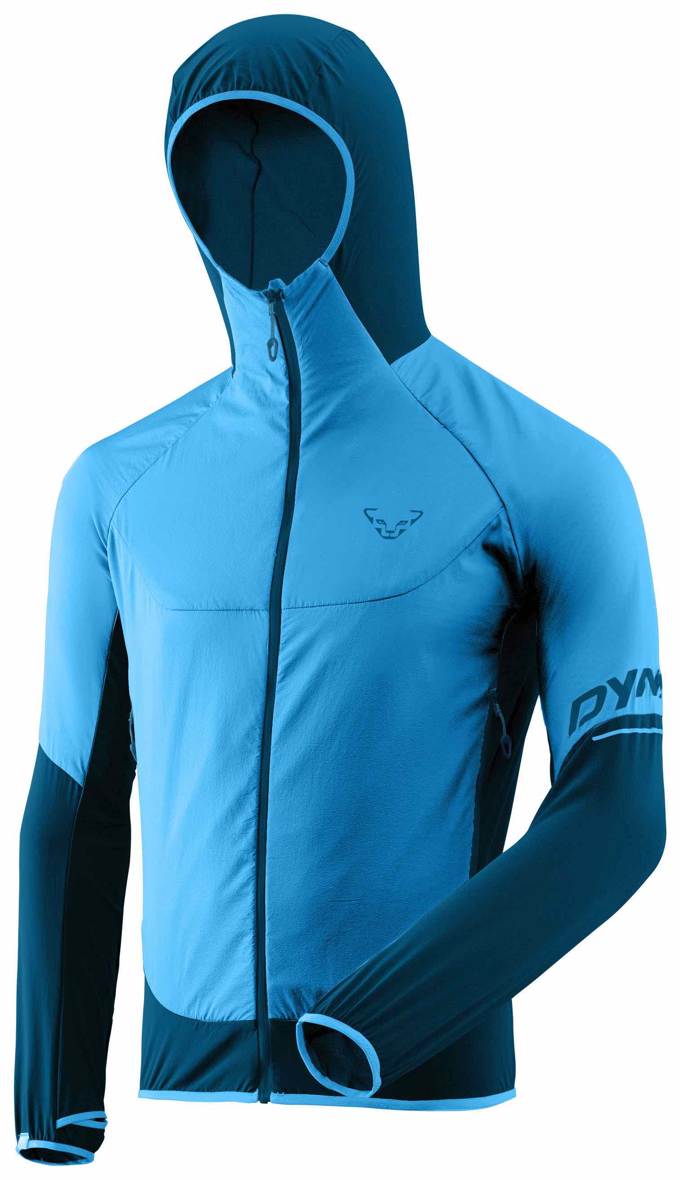
Dynafit
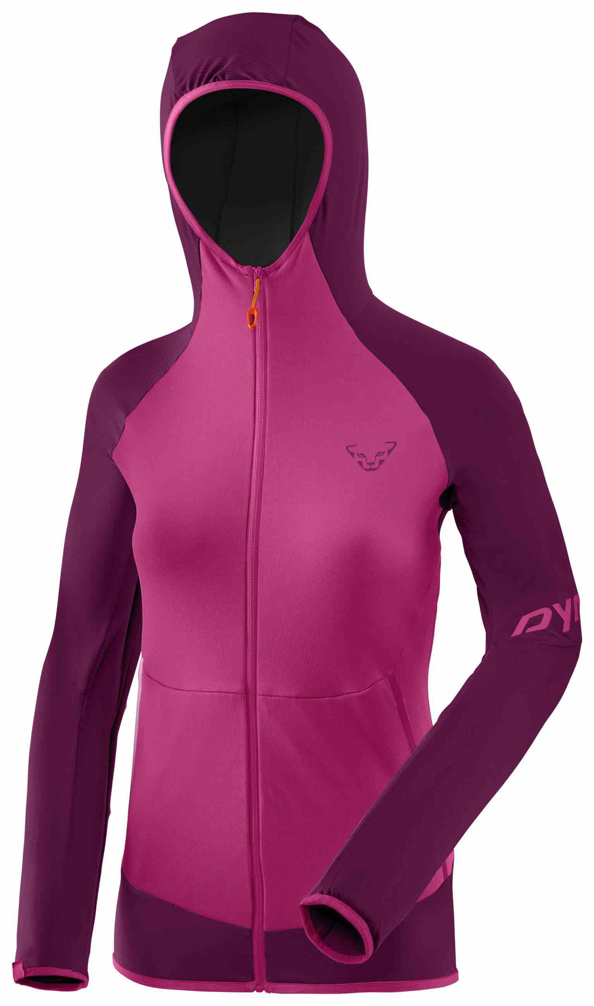
Part of the Salewa Group, Dynafit is headquartered in Munich. With a history based firmly in skiing, Dynafit is an athlete driven brand, producing gear for those 100% committed to mountain endurance sports. Known for their technical excellence it’s no surprise that Polartec sits in the Athletic Mountaineering collection in the Transalper range. Comprising six jackets, both in men and women’s styles, the Transalper Hybrid Polartec Alpha Jacket (pictured right, women’s, pink; men’s blue) uses a technology originally designed for the US Special Forces to provide them with continuous comfort during stop-go activities. Today Polartec® Alpha® is a popular choice for market leading active lifestyle brands because it delivers on-the-go-warmth and eliminates the need to continually shed layers. The other two jackets in Dynafit’s range include the Transalper Thermal Hooded Jacket (M&W) and the Transalper Light Polartec Hooded Jacket (M&W). Both use Polartec® Power Grid™ fabric for lightweight breathable protection. Polartec® Power Grid™ is the evolution of fleece fabric engineering with a patented grid construction knit that strengthens performance efficiency by increasing warmth and breathability, while also reducing fabric mass.

Karpos Outdoor
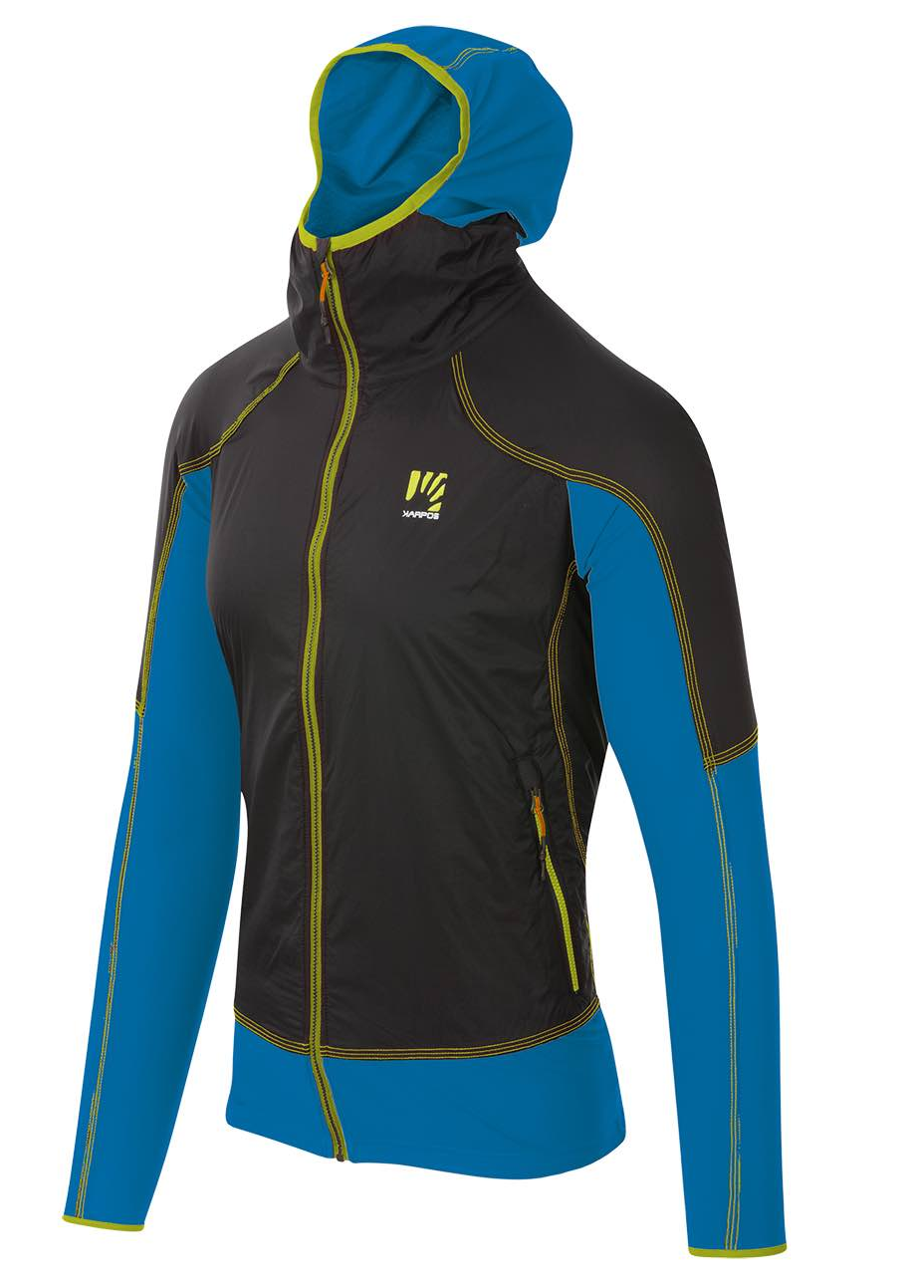
The two new products launched by Italian, family-owned brand Karpos include the Lavaredo Jacket in a men’s and women’s fit which uses Polartec® Alpha® and the Moved Evo Jersey which uses Polartec® Delta™. The Lavaredo Jacket (pictured right, blue, men), with its windproof, DWR outer fabric offers great protection. The Polartec Alpha within offers warmth and breathability resulting in a comfortable jacket suitable to wear throughout spring and summer in a range of weathers. Also available for women. The Moved Evo Jersey has a mesh look thanks to Polartec Delta technology which works on the principle of using the body's natural cooling process — sweat. Next-to-skin fabrics that target wicking and fast drying will keep moisture moving, but don't work towards actually cooling the body down. Delta™ works more efficiently by elevating touch-points for increased airflow, faster moisture dispersal, and reduced wet-cling. The addition of an odour-resistant treatment prevents the growth of micro-organisms hence eliminating unpleasant smells. The Moved Evo Jersey is available for men and women.
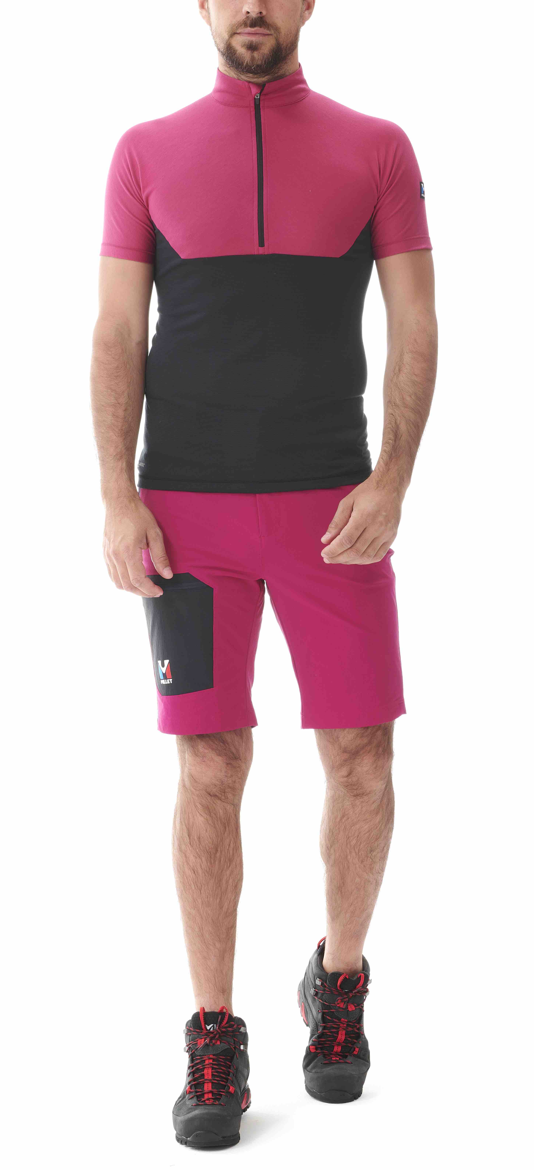

Millet
French-brand Millet has a range of Polartec products in its portfolio but the newest, most exciting is the Trilogy Fragment Zip short-sleeve tee. Again, using Polartec® Delta™, this time in a very lightweight version, this technical mountaineering tee uses a special knit construction that utilises both hydrophobic and hydrophilic yarns for more advanced control of moisture dispersal. These patent-pending, radiating knit structures keep you cooler in hot conditions by increasing airflow to dissipate heat. The streamlined shape of this technical top for men prevents chaffing and the half front zip allows for swift ventilation during fast paced climbs. Other new products in the range include the Morpho zip short-sleeved top in Polartec® Power Dry®, the Trilogy Lightgrid Jacket for women in Power Grid™, the Trilogy de Diamond TS short-sleeve tee in Delta, the Fusion Power Jacket for women in Polartec® Power Stretch® Pro™ and the Fusion Grid Hoodie for women in Power Grid.

Norrøna

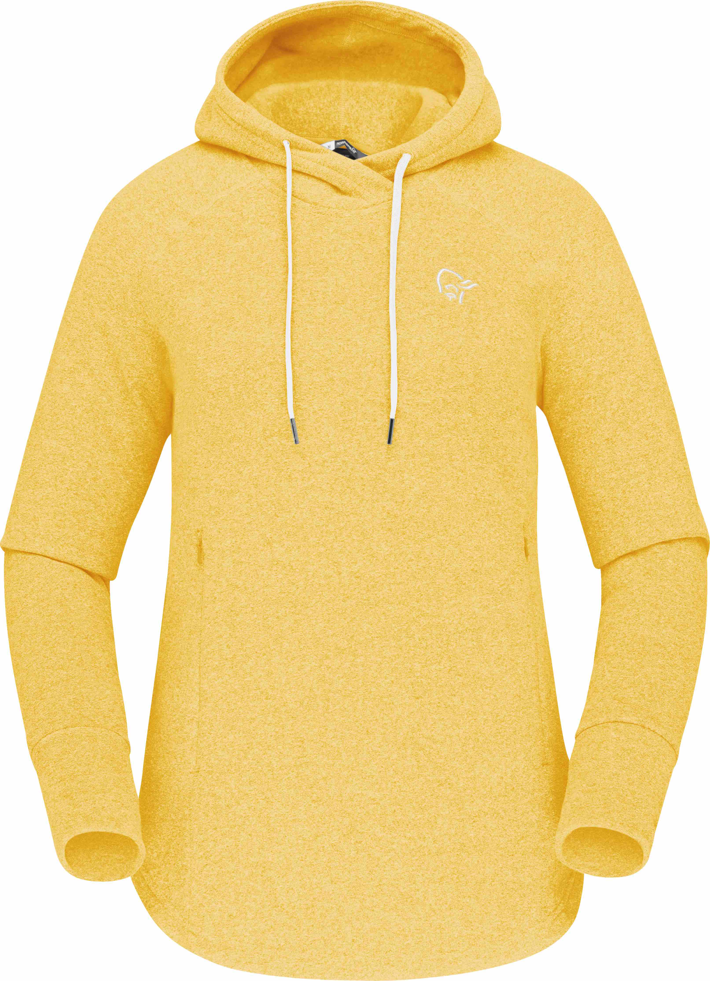
Based in Norway, Norrona was started in 1929 by outdoor enthusiast Jørgen Jørgensen. Today the brand invests in sustainable projects so it goes without saying that the Polartec® Thermal Pro® used in their two new products use a recycled version of the fabric. With comfortable versatility at its core, the classic Norrøna Warm2 hood (pictured right, for women) is a timeless classic. Polartec’s Thermal Pro offers exceptional warmth and comfort on any adventure and is perfect for everyday wear. It’s made from a high quality recycled version of Thermal Pro which sports a knitted face. To date Polartec has recycled over 1.7 billion plastic bottles producing over 200 fabric styles with them since it started recycling plastic bottles in 1993. With its signature minimalist Nørrona design, it sports a snug hood, zipped kangaroo pocket and elasticated cuffs. The Crew Neck (unisex) also offers a clean look and again uses a recycled version of Polartec Thermal Pro with a knitted face. The Crew features articulated elbows for comfort and mobility and has ribbed cuffs and hem.

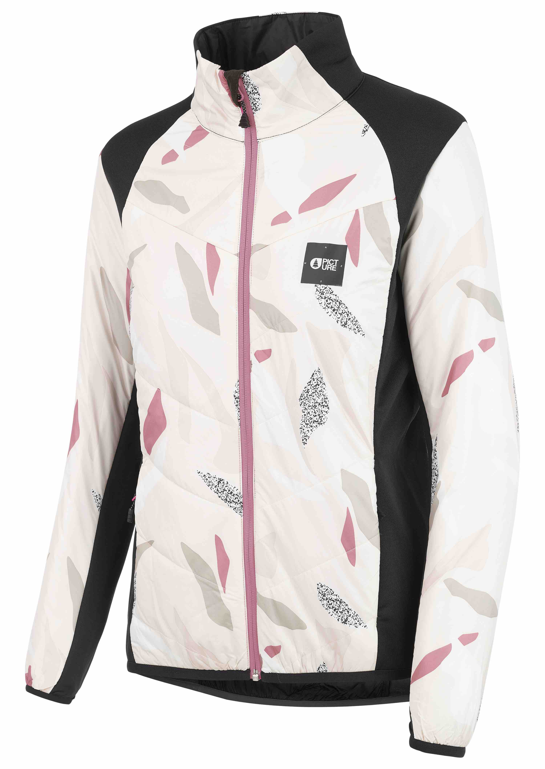
Picture Organic
SALEWith sustainability at its core, fabrics included in the Picture collection have solid sustainability attributes including the three new products made from recycled Polartec fabric. The Takashima jacket (men) and Murakami Jacket (women, pictured left) use a recycled version of Polartec® Power Stretch® Pro™ for unhindered flexibility. The beauty of Power Stretch Pro is its great elastic stretch and recovery. Part of Polartec’s performance fit platform, the advanced dual-surface knit construction gives the fabric enough tensile strength and abrasion resistance to keep it durable and enable it to recover its shape. Performance wicking abilities keep the wearer comfortable and a PFC free DWR treatment protects the outer from showers. Body-mapping construction using PrimaLoft Eco ensures insulation is where it’s most needed. The Lea Vest, also new, uses the above technologies in a sleeveless, hooded format for women.

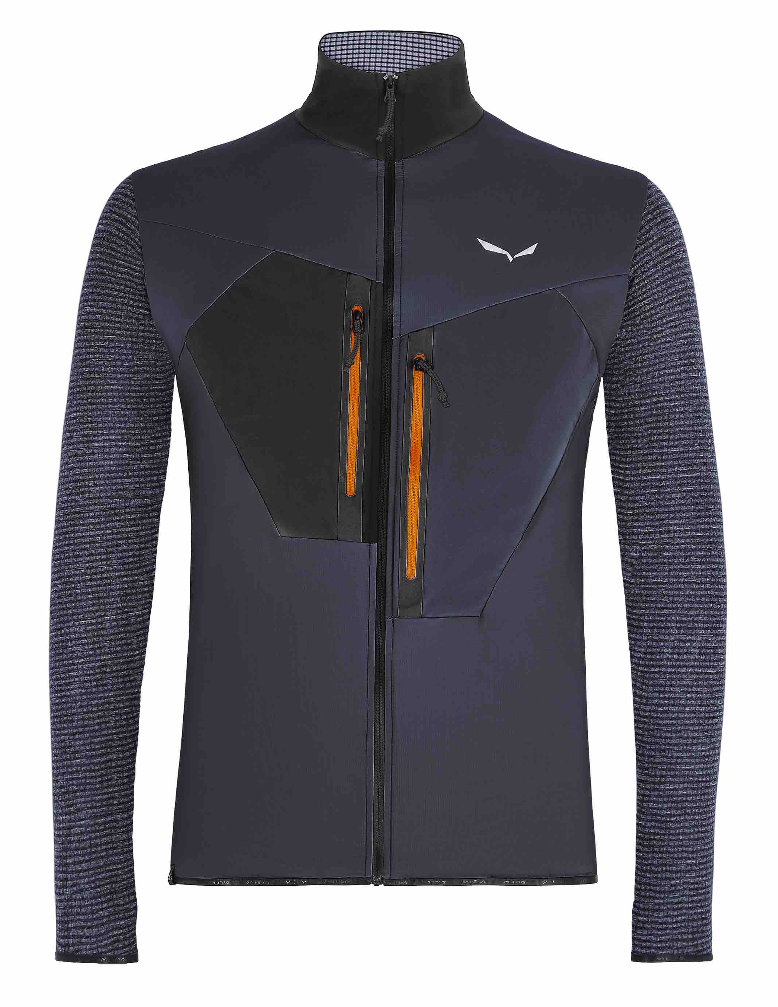
Salewa
Salewa has added the the Pedroc Hybrid 2 PTC Alpha jacket for men and women (pictured right in men’s) to the successful Pedroc range. Using Polartec® Alpha® it has been designed for speed hiking. Using Alpha, as the name suggests, this jacket offers wind resistance, water repellency, breathability, durability and is lightweight. Polartec Alpha lends itself to Speed Hiking, because of the remarkable way in which it can provide warmth during stop-go activities, eliminating the need to constantly shed layers. In addition, because it’s a woven insulation, the face fabric can be lighter and more breathable because the Alpha fibres won’t migrate. The pieces all have a front neck zip, soft inner collar and two slash pockets and each stows in a small, integrated compression pouch. Also available for women.

For further information contact Stephanie Briggs at Spring PR:
Stephanie@springpr.com; T: 07818 063163
About Polartec: Polartec is the premium provider of innovative textile solutions. Since inventing modern synthetic fleece in 1981, the engineers at Polartec continue to create fabric technologies that solve problems and improve the way products are designed and used. Polartec products range from lightweight wicking and cooling fabrics, to insulation and weather protection textiles, and are utilized by leading consumer brands, the U.S. Military and other global militaries, flame resistance, workwear, and contract upholstery markets. For more information, please visit Polartec.com and follow Polartec on Instagram, Facebook and Twitter.

