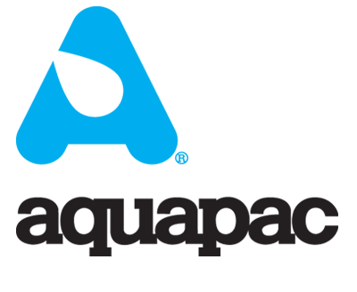
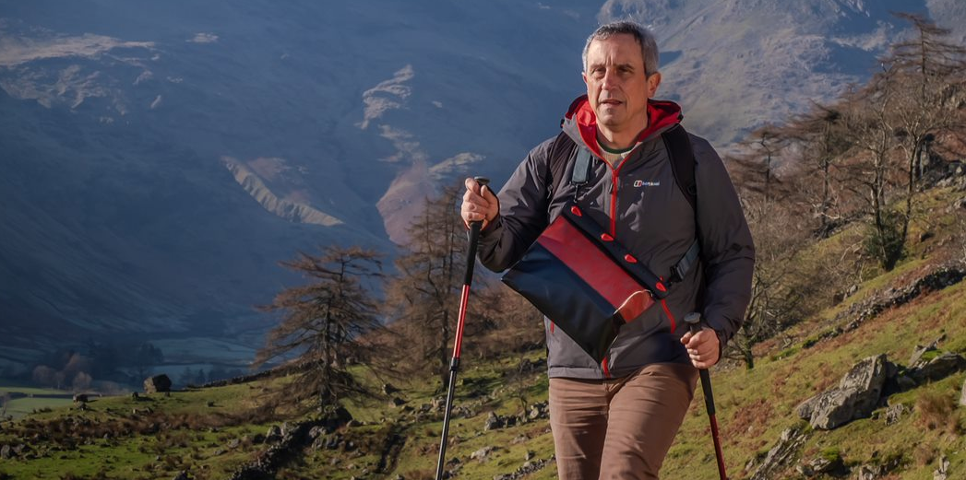

THE TOPO COLLECTION - CASES FOR ALL SEASONS AND INFINITE REASONS

Aquapac, creator of world-class waterproof cases since 1983, are proud to announce the launch of the Topo Collection. This new range of multi-purpose cases comes in nine different sizes and each case has been designed to carry whatever you practically need wherever you are outdoors.

What’s special about the Topo Collection? Your gear will be kept safe from the elements and practical to carry around almost anywhere. Your valuables are easily accessible by virtue of the Aquaclip sealing system, designed to open and close thousands of times. These cases are 100% waterproof to 10 metres (and the smallest to 50 metres!) for up to 30 minutes and made from biodegradable TPU material that’s also UV-resistant and can handle temperatures from -20° Celsius to 50° Celsius.

The smallest case, the Ben, is ideal for keeping personal essentials such as keys, cash and cards while the largest, Everest, will fit clothes, maps, food, drink and more. All [except the Ben] have internal pockets which are either card or passport sized.
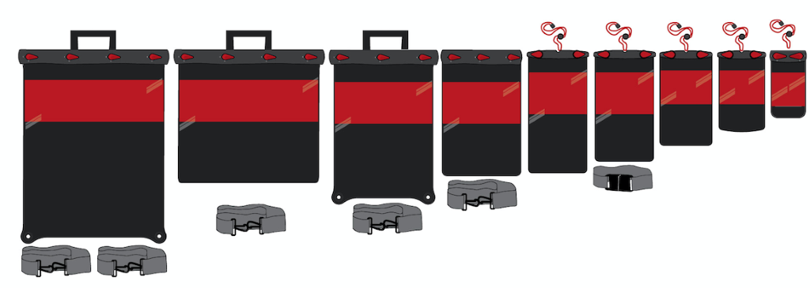
Depending on the size, there are suitable ways of carrying your Aquapac supplied. Anything from an adjustable lanyard for around your neck, a waist belt, a shoulder strap, a detachable carry handle and even eyelets to tie down a case with elasticated cord onto a kayak or RIB.

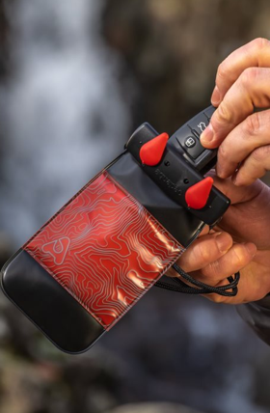
Why Topo? The name ‘Topo’, short for topographical, has been selected due to the classic black and red stripe contour-style design on the cases keeping your belongings discreetly hidden from the outside. Following this, Aquapac have decided to name each product in the range after a mountain in size order - ‘Ben’, short for Ben Nevis, is the smallest case with ‘Everest’, the largest.

Aquapac Topos provide a solution whether you are hiking, skiing, surfing, travelling around the world or moving around in town. Aquapacs are used by mountain guides, the RNLI, Coast Guards, Search and Rescue Teams and on expeditions worldwide; trusted by professionals, designed for the outdoors.

MPC10 - The Ben: Ben Nevis is the smallest case in Aquapac's range, despite being the tallest mountain in the UK at 1,345 metres. In memory of Ben Parker, one of the Founder Members. Size: 85 x 165 mm. RRP: £15.99.
MPC20 - El Capitan: A classic monolith from Yosemite – a hikers must-see – is 2,307 metres. The El Capitan case has enough room for the small essentials and is also available with a transparent back for mobile phone use.
Size: 115 x 190 mm. RRP: £17.99/£19.99 (transparent back).
MPC30 – Olympus: A 2,918 metre mythological mountain in Greece. The Olympus case fits a phone with your camera as well as your passport. £19.99.
Size: 130 x 230 mm
MPC40 - The Debbie: Mount Deborah towers at 3,761 metres. A challenging Alaskan peak to climb. In honour of Debbie, Aquapac’s Production Manager of 25 years.
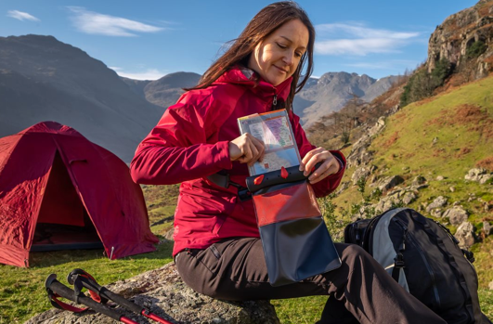
Size: 150 x 200 mm. RRP: £24.99.
MPC50 – Fuji: At 3,776 metres, Mt Fuji is iconic and sacred to Japan. This year, Aquapac are celebrating 25 years of selling in Japan. Big enough to carry most things and hang around your neck.
Size: 150 x 295 mm. RRP: £21.99.
MPC60 – Matterhorn: Famed for its symmetry and beauty, Matterhorn is 4,478 metres in height. Fits a 10-inch tablet too.
Size: 200 x 290 mm. RRP: £29.99.
MPC70 - Mont Blanc: The biggest mountain in Europe at 4,808 metres. A perfect travel case.
Size: 250 x 380 mm. RRP: £34.99.
MPC80 – Kilimanjaro: At 5,885 metres, the tallest in Africa, Kilimanjaro is a stand-out mountain and case.
Size: 350 x 295 mm. RRP: £35.99.
MPC90 – Everest: A colossal 8,848 metres, Mt Everest is the highest mountain for the largest case. A truly versatile case: wear it on your back, over your shoulder or carry on a handle as well as tying it down.
Size: 350 x 430 mm. RRP: £44.99.

For further press information contact: abbie@springpr.com.
For prices and catalogues contact: sales@aquapac.net.

Aquapac has been making waterproof cases since 1983. Some of their most popular ranges are for mobile phones, VHF radios and radio mics. All these devices are carried around and used daily in all kinds of environments; from fully immersed to the tops of mountains, or in a kayak or, boat, in occasionally extremely hostile conditions. Aquapac have always designed practical carrying systems into their product ranges since day one but users constantly push the envelope.

