UK Media Contact:
Abbie Baynes | Spring PR
abbie@springpr.com | 01666 824180
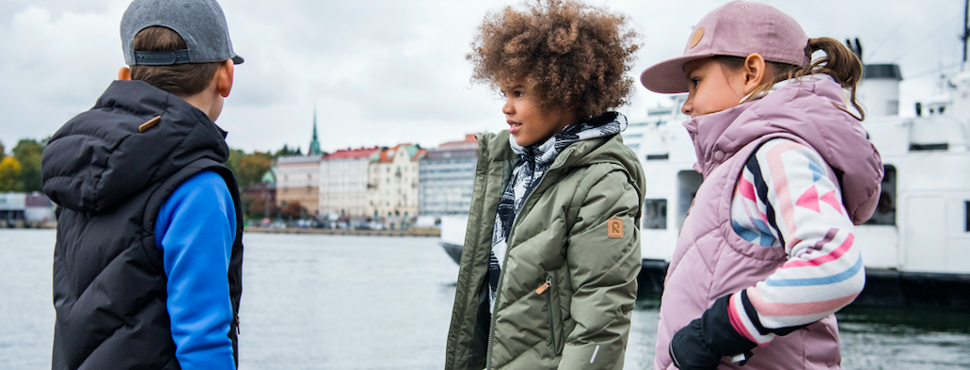
Reima recycles coffee beans to technical outerwear
Reima puts strong emphasis on innovation and sustainability, combining these two in its novelty for this autumn: a special fabric that stores heat.

Coffee to keep kids warm? Yes!
When tiny particles of coffee beans are carbonised at high temperature, the carbon forms honeycomb structures. By adding those particles into polyester, textile engineers have been able to increase its heat retention capability – just like a cup of hot coffee can warm you internally!
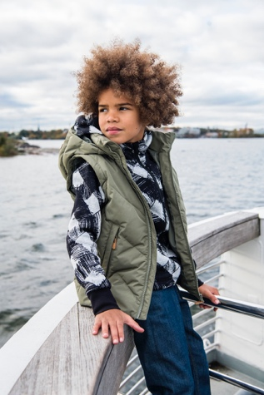
The small, hollow honeycomb-structured carbon particles in the fabric can store heat. This phenomenon is pretty much the same thing that happens to a car, when it gets very hot in the sun and keeps the heat inside. Besides storing heat, the carbon will decrease the build-up of static electricity in the fabric and prevent the formation of odours.

The ‘Coffee Bean Shimmer’ fabric is made from 100% polyester with a waterproof, breathable PU lamination, so the products are a great match for changing autumn and winter weather. The fabric has a water pillar of 5 000 mm and a breathability of 6 000 g/m²/24 h, which make it both protective and comfortable to wear for active kids. The products are made water and dirt repellent using the DWR finish BIONICFINISH ®ECO without fluorocarbons, which allows parents to wash less. However, for more convenient washing and quicker drying, the products are tumble dry proof too.
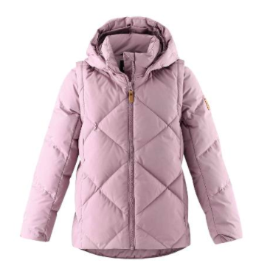
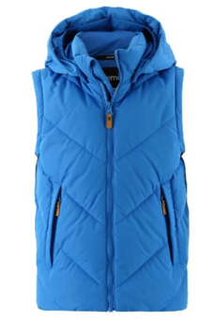
Reima’s 2-in-1 down jackets start off as gilets [Beringer, far right] in September, looking good when dressed for example on top of a fleece sweater. The gilets quickly become warm winter jackets by simply adding on the sleeves [Heiberg, right]. Reima offers two styles: the slimmer ‘Heiberg’ and straight cut ‘Beringer’ with 3 colour options each, in sizes 104 - 164 cm. RRP: £100.00.

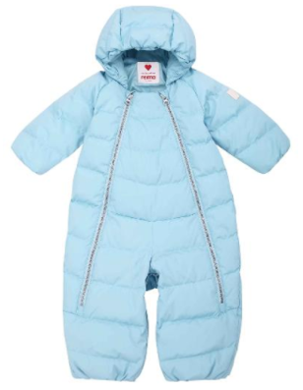
Another product made from the same material is the winter one-piece ‘Honeycomb’ [left] belonging to the Reima Newborn Collection, in sizes 56/62 – 68/74 cm. You can use the garment as a sleeping bag for the baby, or easily transform it into an overall with legs – just by closing the genius zip in the leg inseams in two alternate ways. RRP: £100.00.

All these products are insulated with Responsible Down Standard certified down and feathers, so they are sure to warm up hearts too. The fill power of the insulation is 550.

Reima is a globally leading kids' activewear brand. Founded in Finland in 1944, Reima employs around 500 people. The company’s turnover was €141 million in 2019. Reima’s products and Finnish Baby Box solutions are available in over 70 countries. Reima’s mission is to gear up the next generation of happy, active kids, preparing them for the world to come. Our design principles are innovation, functionality, safety, and fresh Finnish design. The clothing is approved by the world’s toughest testers: children. Read more at www.reima.com

